Quantified Student

A/B Usability Test Findings



Created by G. Malisz

Spis treści

1. Version History 1

2. Overview 1

3. Layout 1 2

4. Layout 2 2

5. Student Preferences 2

6. Data Sources Findings 4

7. Conclusion 5

8. Definitions, Acronyms, and Abbreviations 5

# Version History

|  |  |  |  |
| --- | --- | --- | --- |
| Version | Date | Author | Comment |
| 0.1 | 07.06.2023 | G. Malisz | First iteration of this document. Overview, Layouts, Student Preferences, Layout 1 Findings, Layout 2 Findings and Conclusion. |

# Overview

An in-person A/B Usability Test was conducted to further evaluate the two layout designs (Layout A and Layout B) for the student performance dashboard. Building upon the insights gained from the first General Usability Test, this A/B test aimed to gather more detailed feedback and observations from participants. The test sessions were conducted in person, allowing for direct interaction with the layouts and facilitating real-time feedback collection. The layouts were enhanced with dynamic interactions, allowing participants to experience the interactive elements and functionalities of the dashboard. The feedback obtained during the first General Usability Test was also taken into account to address any identified usability issues and refine the layouts accordingly. This A/B Usability Test provided an opportunity to observe participants' preferences, navigation patterns, and overall satisfaction with each layout design.

A/B Usability Test can be found in the **QS - Dashboard A-B Usability Test.pdf** file

# Layout 1

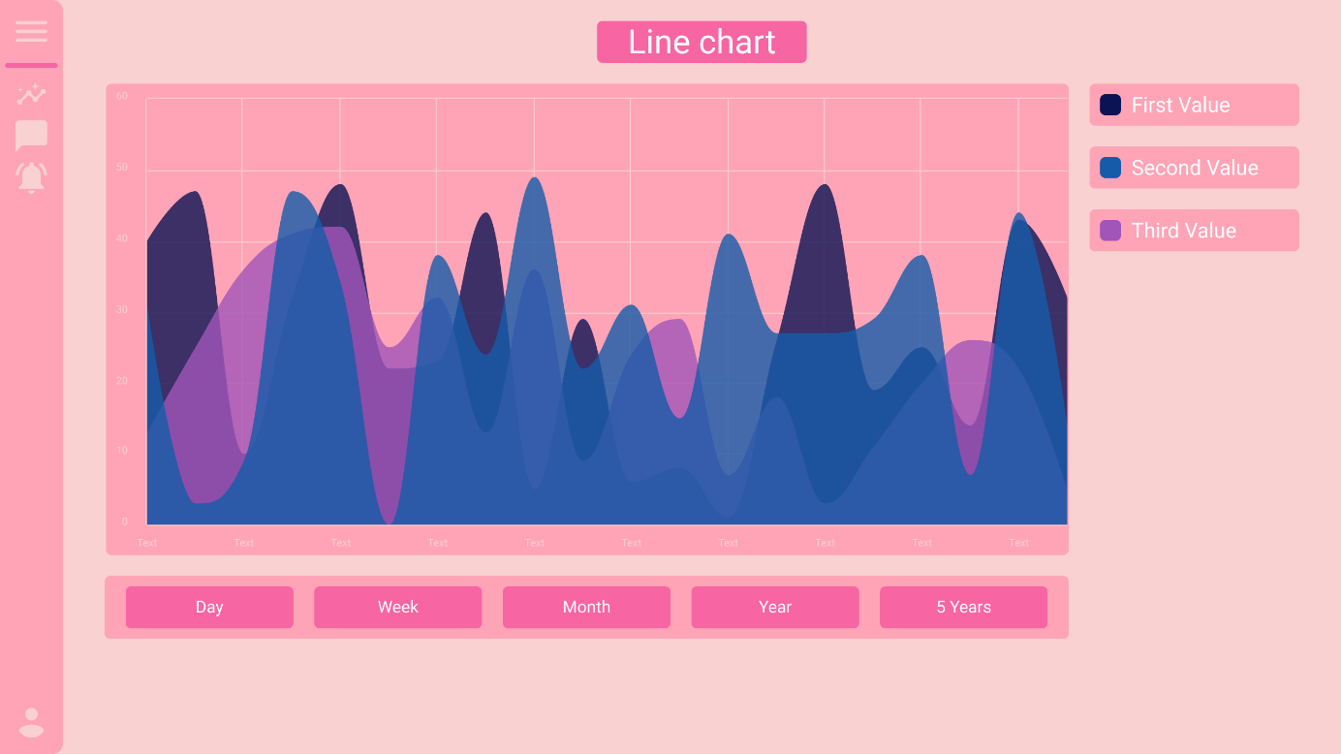

# Layout 2

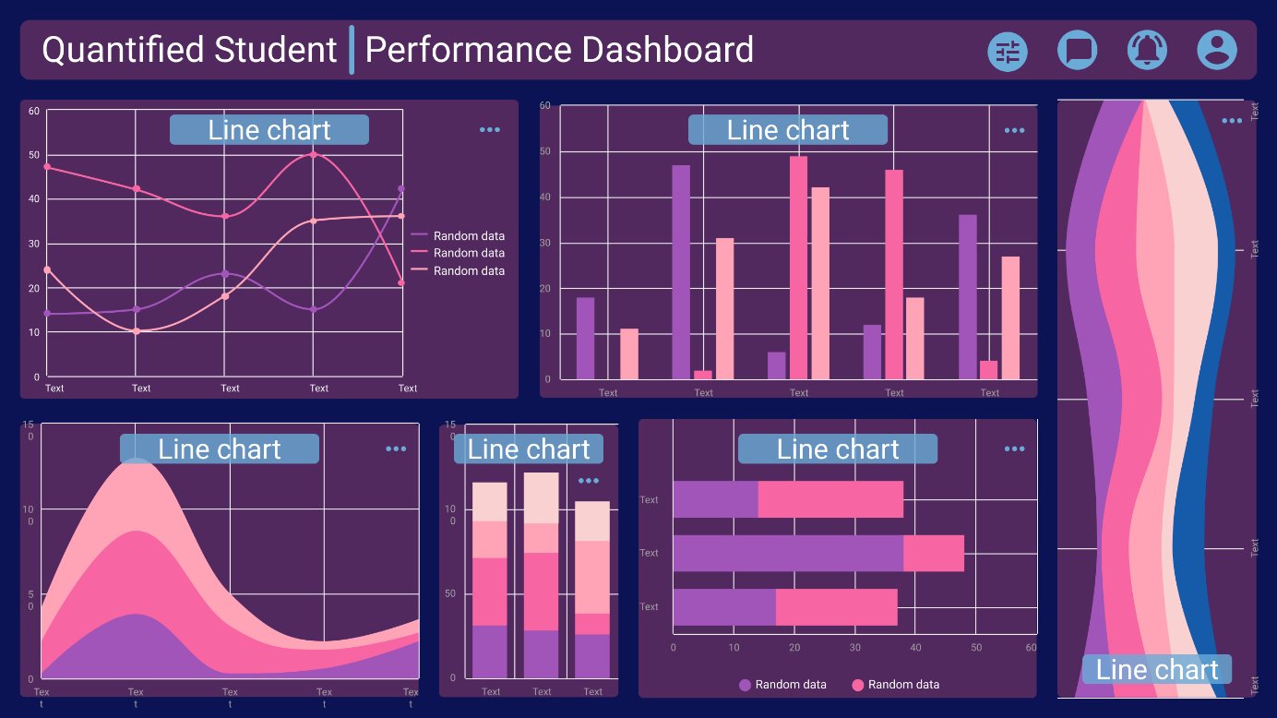

# Student Preferences

Based on the feedback gathered from the A/B Usability Test, Layout 2 was chosen as the preferred option for the student performance dashboard. The majority of the students expressed their approval for Layout 2, highlighting its intuitive structure, quick access to relevant information, and interactive elements. However, it was noted that some refinements would be necessary to align it more closely with the specific requirements and preferences of the students. Taking into consideration the valuable input received, the development team will work on refining Layout 2 to ensure it fully meets the students' expectations and delivers an optimal user experience.

The snippets from the General Usability Test Findings are displayed below. Whole General Usability Test Findings can be found in the **QS - General Usability Test Answers.pdf**

# Layout 1 Findings

During the interviews students pointed out couple negative aspects of Layout 2:

* Viewing Multiple Graphs: Students expressed a desire to view multiple graphs simultaneously within the dashboard. They felt that being able to compare and analyse different graphs side by side would provide a more comprehensive understanding of their performance and facilitate data-driven decision-making.
* Bright Colours: Some students provided feedback indicating that the colours used in Layout 1 were too bright or vibrant. They expressed concerns that the high intensity of colours could be visually overwhelming and distracting.
* Colour Accessibility: Another concern raised by students was related to the colour choices in Layout 1, particularly for individuals with colour blindness. They noted that some colours appeared too similar, making it challenging to distinguish between different data elements or categories.
* Excessive Navigation: While students acknowledged that navigation within Layout 1 was straightforward and easy to use, some also mentioned that there were too many navigation elements present. They felt that the abundance of navigation options could lead to confusion or make the interface feel cluttered.

# Layout 2 Findings

During the interviews students suggested couple of changes in the Layout 2:

* Students expressed concerns about the potential for the dashboard design to become cluttered in the future, even though they did not find it cluttered in its current state. They emphasized the importance of proactively addressing this issue to maintain a clean and organized interface as the system evolves. Taking this feedback into account the layout will be carefully assess and anticipate future growth. Strategic adjustments will be made to improve the visual hierarchy, spacing, and overall organization of elements. By proactively addressing this concern, the student performance dashboard will continue to provide a streamlined and intuitive user experience, ensuring that information remains easily accessible and comprehensible, even as new features and data sources are added over time.
* Graph Enlargement Indication: Students suggested the inclusion of an indication of the feature that allows for the enlargement of graphs for more detailed analysis. This feedback reflects the importance of providing students with the ability to view graphs in a larger format, facilitating better comprehension and interpretation of data. Dedicated button for graph expansion will be incorporated in the final product, to address this suggestion. By implementing this enhancement, students will have the flexibility to focus on specific data points and gain deeper insights into their performance trends.
* Light Theme: Some students expressed a preference for a light theme option in the dashboard interface. This feedback underscores the significance of customization and catering to individual user preferences. To meet this demand, light theme variant will be introduced alongside the existing dark theme. This choice will allow students to personalize their dashboard experience and ensure readability and visual comfort for people with for example colour blindness.
* Intuitive Dashboard Customization Icon: Students provided feedback regarding the need for a more intuitive icon or button to access the dashboard customization options. This suggestion aims to enhance the ease of customization and personalization for students. An alternative iconography or intuitive visual cues that clearly represent the customization feature will be incorporated, ensuring that students can effortlessly personalize their dashboard settings to suit their unique needs and preferences.

# Conclusion

The findings from the A/B Usability Test regarding the preference and pros and cons of different layouts provide valuable insights and serve as indicators for changes in the Dashboard Development. Based on the feedback received, Layout 2 emerged as the preferred option among the students. However, it is important to note that both layouts had their strengths and weaknesses, which will be taken into consideration during the decision-making process. These findings will guide the Dashboard Development team in refining Layout 2 to fully match the students' requirements and create a more optimized and user-friendly student performance dashboard. By incorporating these valuable insights, the Dashboard Development can ensure that the final product meets the expectations of the users and provides an enhanced experience for data analysis and visualization.

# Definitions, Acronyms, and Abbreviations

|  |  |
| --- | --- |
| Abbreviation | Meaning |
| QS | Quantified Student |
| Microservice | Small independent services that communicates with Application |